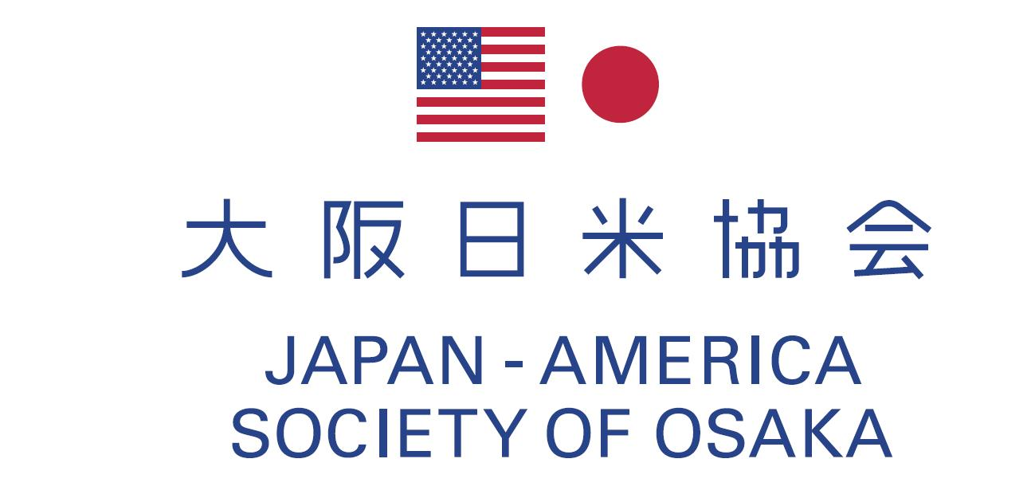
June 20, 2013

Dear Members,

2013 Annual General Meeting

I am pleased to announce that we will hold 2013 Annual General Meeting on Tuesday, July 30 at RIHGA Royal Hotel Osaka. Among agendas to be discussed are reports on the activities that took place during the fiscal year of 2012 and event proposals for the fiscal year of 2013.

Following the Meeting we will have a reception over the splendid food served by the RIHGA Royal Hotel for getting to know with new members, mingling with the old faces and catching up with latest news.

I look forward to your participation and seeing you at the event.

Sincerely,

Shingo TORII
President
Japan-America Society of Osaka

＊ ＊ ＊
Date & time: Tuesday, July 30, 2013
17：00 Registration desk opens
17：30～18：00 Annual General Meeting
18：00～20：00 Reception
Place: RIHGA Royal Hotel Osaka 3F, “KORIN”
Fee: Member \8,000 / non-member \10,000 / American Student member \1,000

Fill in the form below and send back to us via fax or email no later than Tuesday, July 23, 2013
Sign-up fee should be paid through bank transfer by Tuesday, July 23, 2013
Please note that the cancelation deadline is on Tuesday, July 23.

Mitsubishi Tokyo UFJ Bank, Osaka-Eigyobu,
Account no. Futsuu Kouza 0277905, Account name: Osaka Nichibei Kyokai

Fax 06-6346-0178 Email jaso@suntory.co.jp
Member’s name

Member

If the guest is a member, please check the box.

Total amount ￥
d
〒530-8203 大阪市北区堂島浜2-1-40 サントリーホールディングス株式会社内
c/o Suntory Holdings Limited, 2-1-40 Dojimahama, Kita-ku, Osaka, 530-8203
Tel: 06-6346-6164 Fax: 06-6346-0178 Email: jaso@suntory.co.jp http://www.jaso-1946.com

